1.



(1a)MAP estimation (1b)Target

Iteration Times = 18020(number of samples)

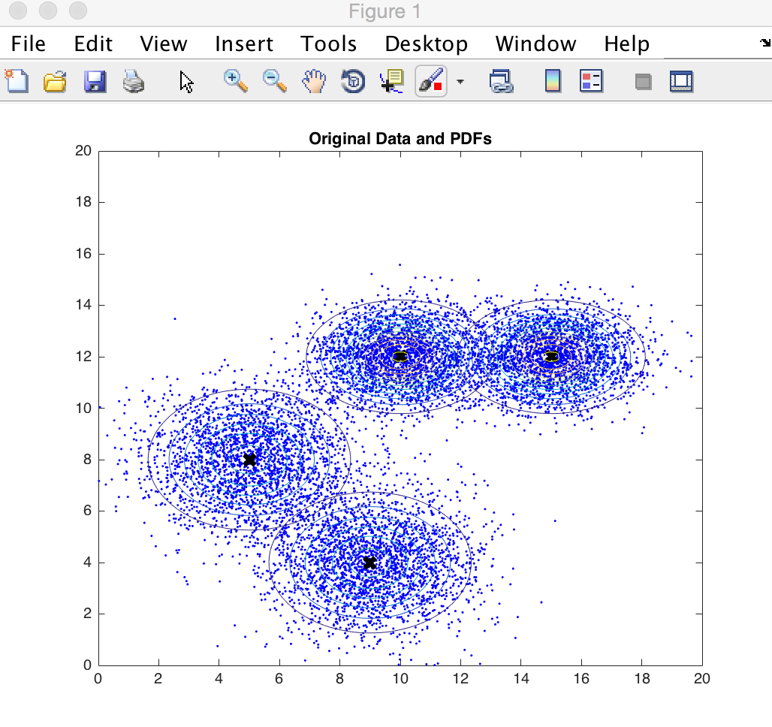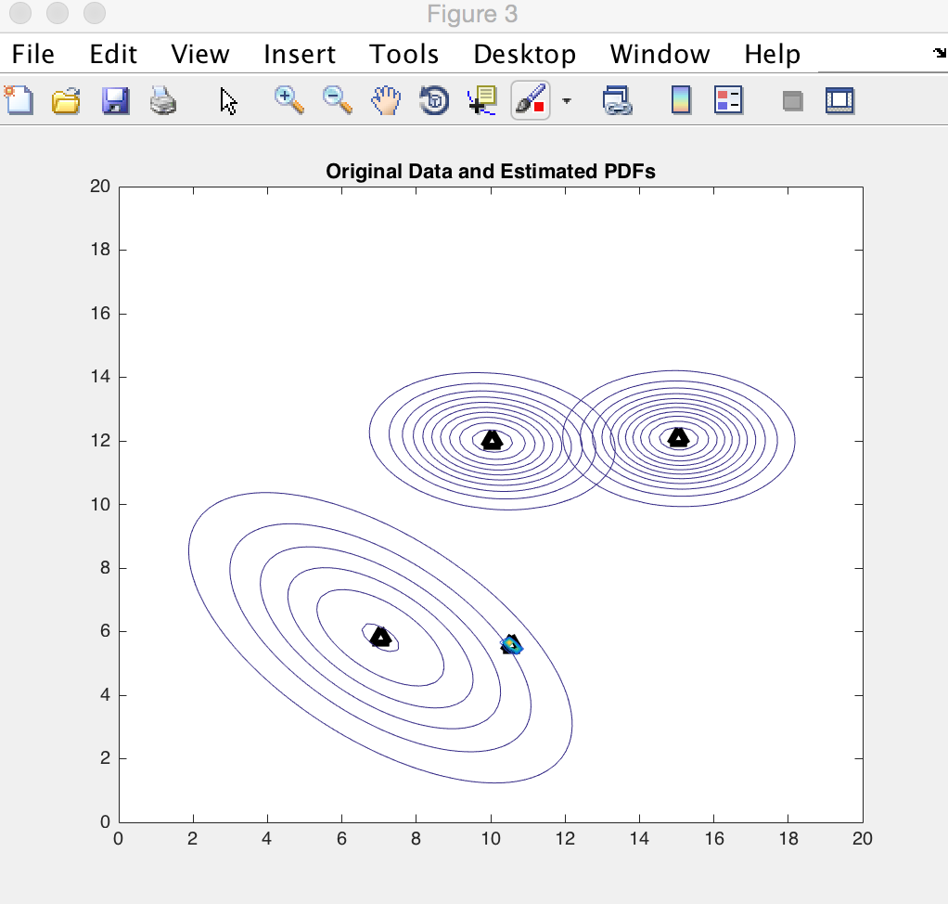

(2a)MAP estimation (2b)Target

Iteration Times = 6950(number of samples)

&Converged

2.Gradient Descent

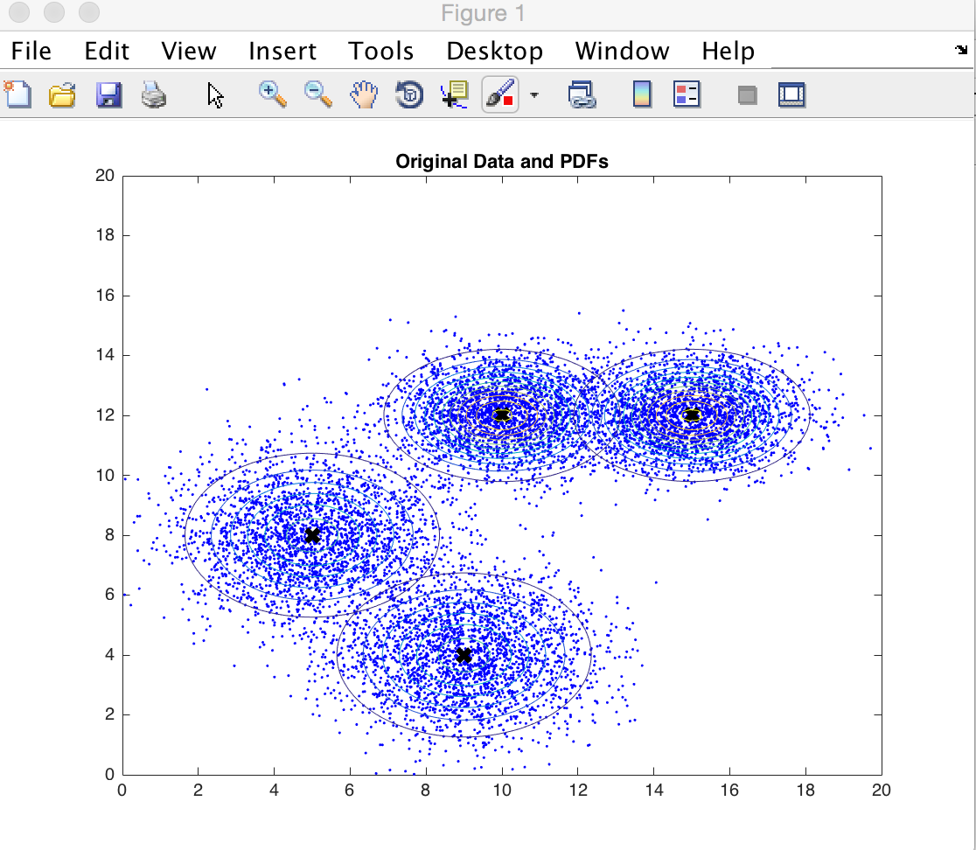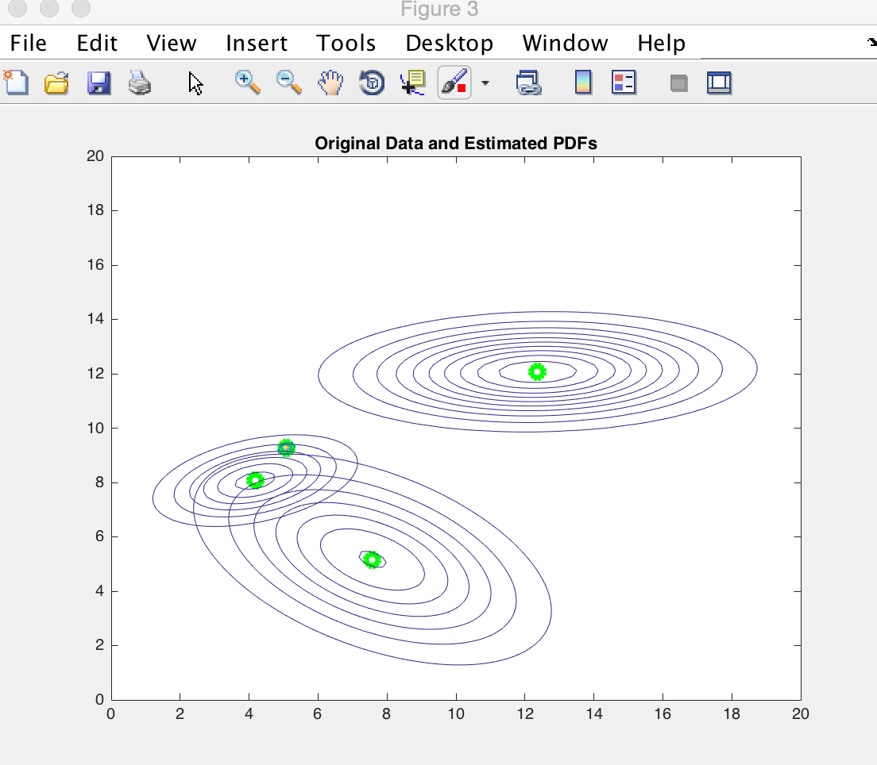

(3a)MAP estimation (3b)Target

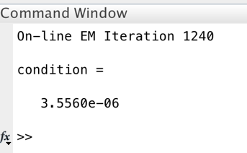

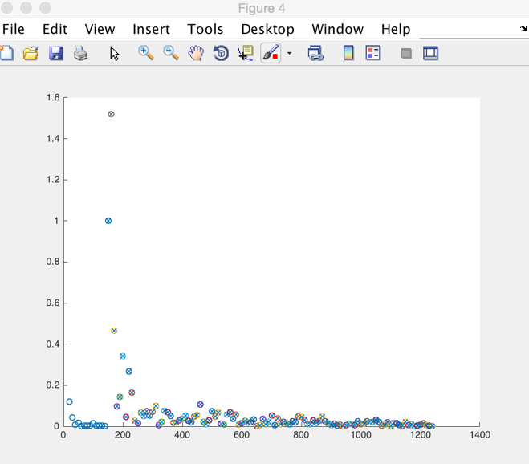

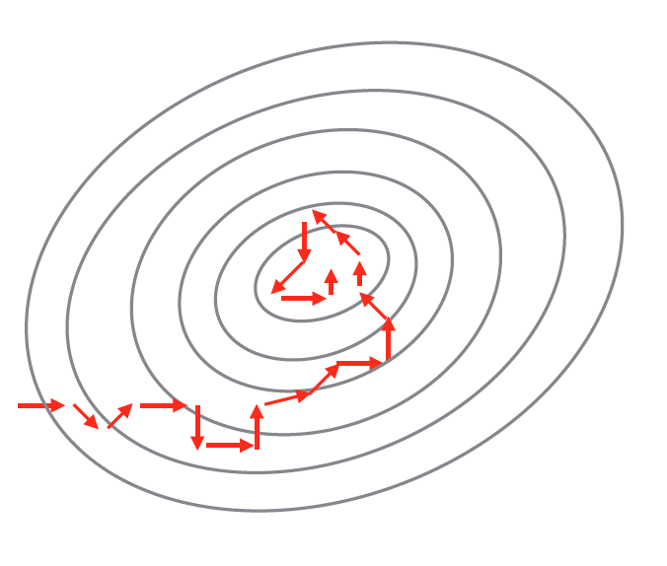

(4a)likhood/prevLikhood-1 (4b)Stochastic gradient descent

follow less optimal directions;

make more moves





(5a)MAP estimation (5b)Target





&not converged

(5c)likhood/prevLikhood-1